

LATROBE UNIVERSITY

BACHELOR OF INFORMATION AND TECHNOLOGY

SYDNEY, 2019

**User Manual for Room Availability and Booking System**

Team: Market Leaders

Jay Tanna, 18884904@students.latrobe.edu.au

Minh Tien Thinh Phan, 18870552@students.latrobe.edu.au

Saurav Thapa, 19136038@students.latrobe.edu.au

Md Sabir, 19122071@students.latrobe.edu.au

Phurba Tsering Sherpa, 19160261@students.latrobe.edu.au

Contents

Overview 3

1. About Navitas Room Availability and Booking System 3

1.1 Organization of the Manual 3

1.2 System Summary 3

1.3 User Access Levels 3

2. Getting Started 4

2.1 Installation and logging in 4

2.2 Login Page 4

2.3 Home Page for Users 5

2.3.1 Booking a Room. 6

2.3.2 Bookings 6

2.3.3 Editing Profile Data 7

3.0 Logging in as Admin 8

3.1 Creating a User – Admin 9

3.2 Viewing Booking Request – Admin 9

3.3 User’s List – Admin 10

3.4 Reply to Feedback – Admin 10

3.5 Dashboard – Admin 10

# Overview

# About Navitas Room Availability and Booking System

Navitas Room Availability and Booking System (NRABS) is an easy-to-use system that helps a user book available room easily and automatically. It gives you the power to

* **Make Room Bookings** – You are provided list of available rooms to choose from with the equipment’s they have and more if you require.
* **Facilitate user signup** – The users have to be created by the admins from the higher levels, so it creates a in house system.
* **Reply to feedbacks** – Feedbacks about a room and its equipment can be send to admin which then can be replied at an instant.
* **Book for long time** – NRABS also allows you to book the room you require for a semester period (3 months)
* **Choose date** – NRABS has a calendar to choose date and see dates for which rooms are already booked, hence saving you time and provides alternatives.

# 1.1 Organization of the Manual

NRABS is designed as 2-way communication where the system acts as a medium to transfer information. Henceforth, the manual will be divided as for the Admins and the Users (Lecturers).

# 1.2 System Summary

NRABS operates on the internet which can be visited via mobile phone, computer or tablets. It runs on every single OS and can only be used by the Admins and Users. Internet connection is required to use the services of the system.

# 1.3 User Access Levels

Admins can make the decisions on the system whereas Users can send the request and feedbacks on the status of room and its equipment. Only authorized admins and users can login to the system.

# Getting Started

Getting started section explains how to get to the system. The section also presents briefly on the system.

# 2.1 Installation and logging in

No installation is required as NRABS is an online system. Internet connection on device is required to access the system. Login for the Admin and Users are required along with their password. The admin first signs up for the system and hence he can create login details for users.

# 2.2 Login Page

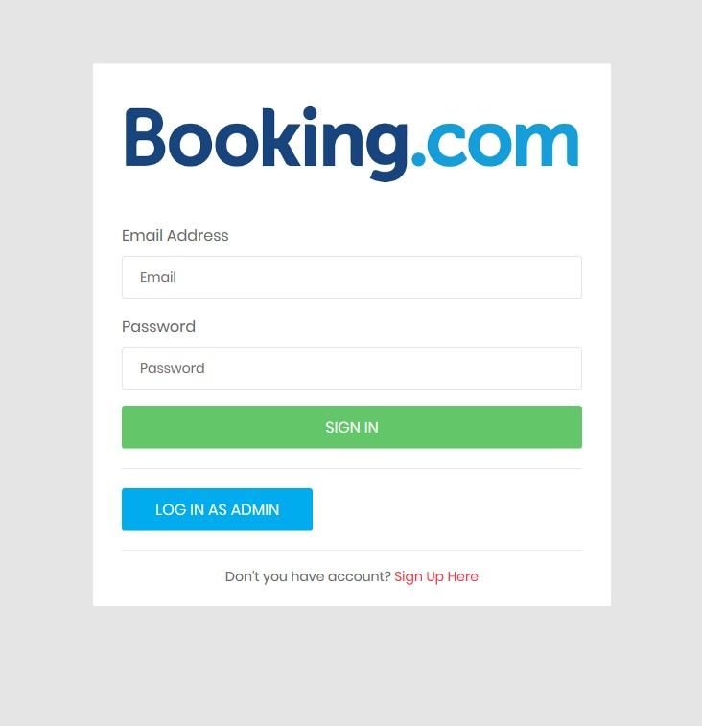

1. Click to login
2. Enter your password
3. Enter your Email here

EE

# 2.3 Home Page for Users

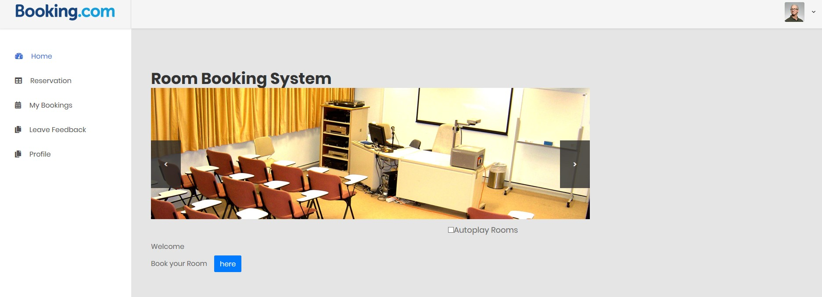

* Reservation allows to reserve or book a room for a date.
* My Bookings shows the rooms you have booked in a calendar.
* Leave Feedback helps to leave a feed back for a room.
* Profile allows you to change your detail.

# 2.3.1 Booking a Room.

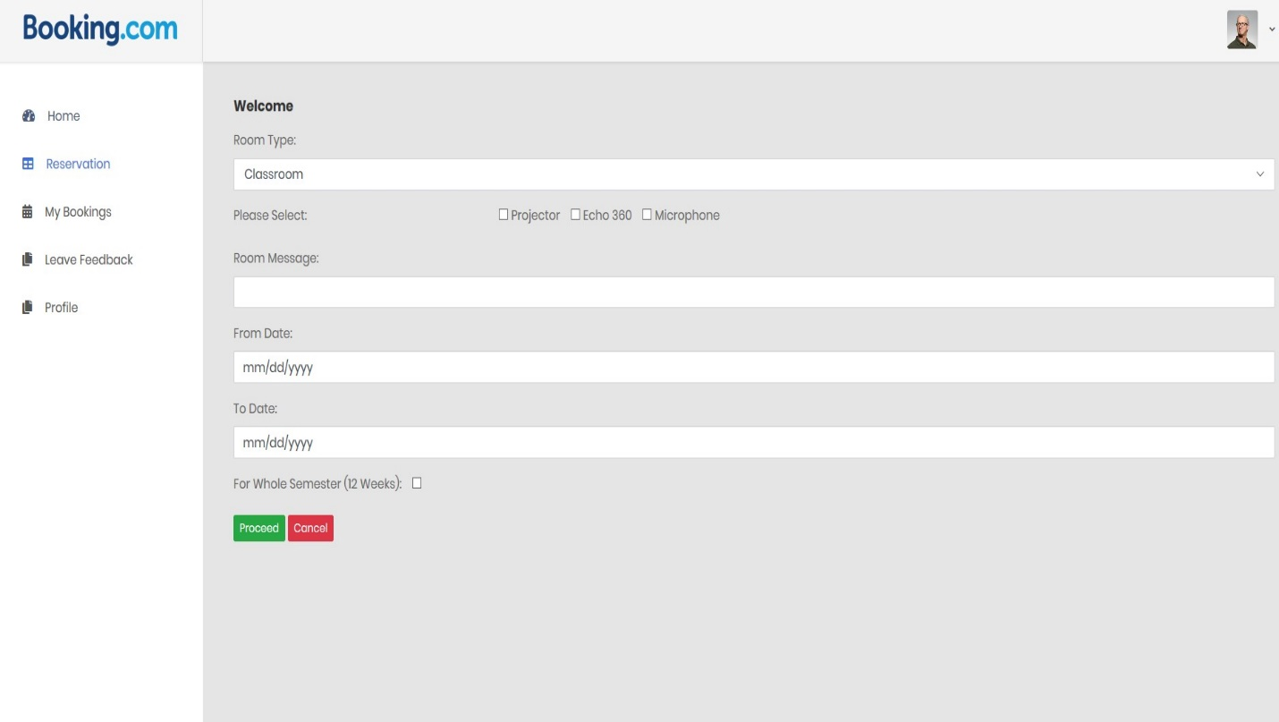

1. Tick the box if you require it for the whole semester
2. Click Proceed to Book
3. Enter the date you require it till
4. Enter the date you need the room from
5. Enter your message to the admin
6. Tick Equipment you require.
7. Enter the type of room you require

# 2.3.2 Bookings

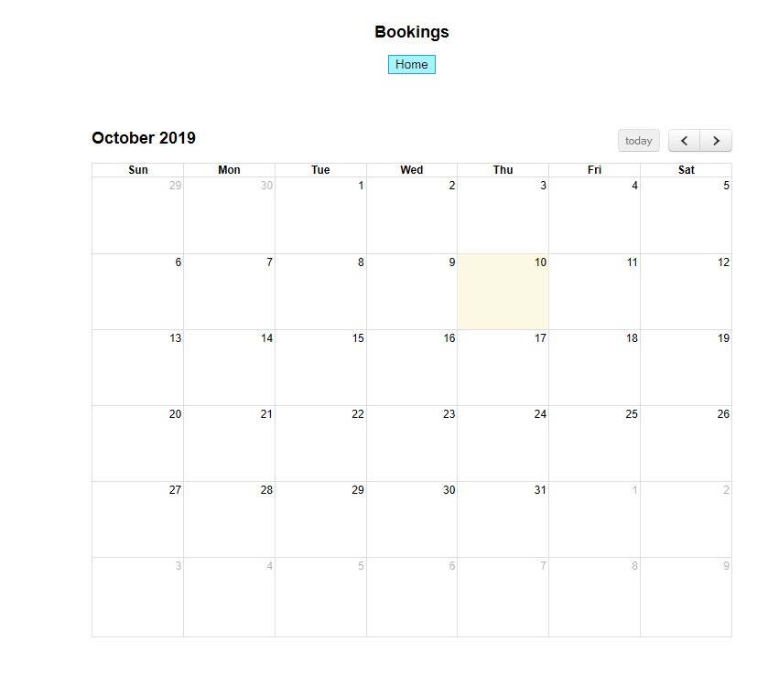

# 2.3.3 Editing Profile Data

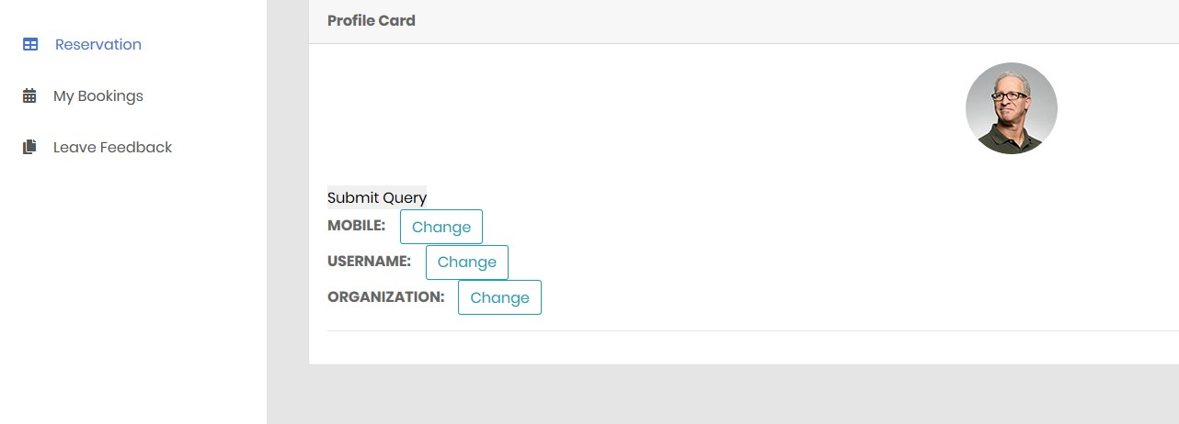

1. Click on any of those buttons to edit your detail

# 3.0 Logging in as Admin

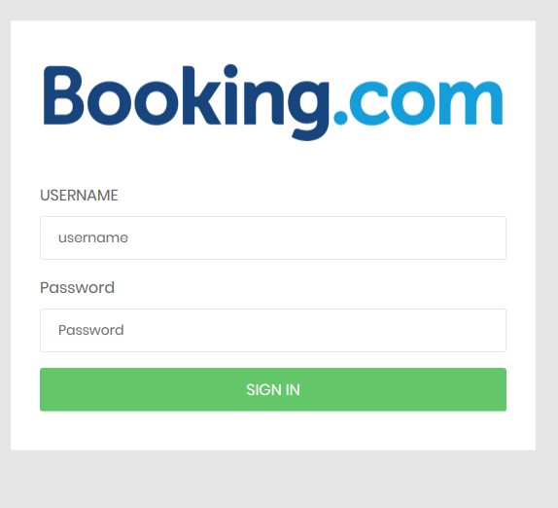

1. Click on Sign in to login
2. Enter Password
3. Enter admin user name

# 3.1 Creating a User – Admin

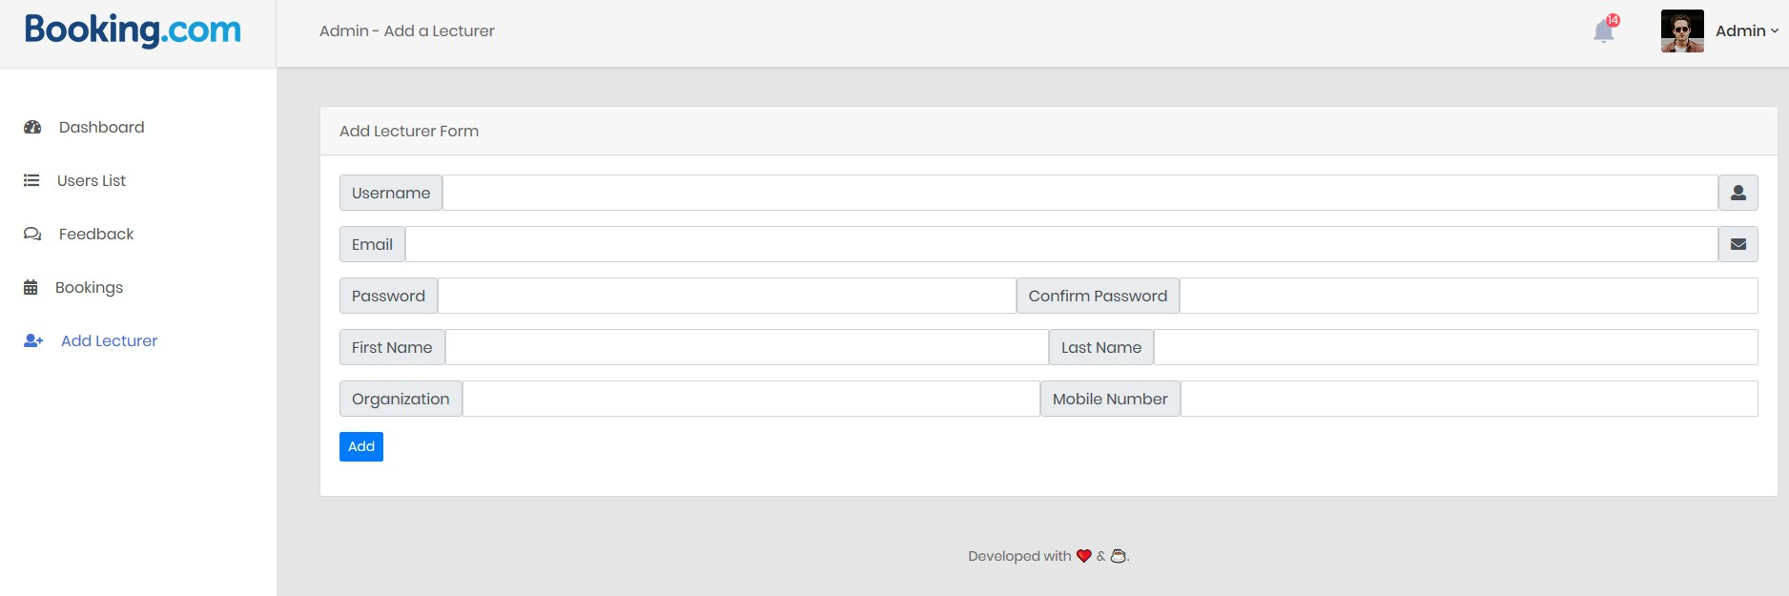

1. Click on Add to Finalize the User account creation
3. Enter Users mobile number
4. Enter Organization User is in
5. Enter Last name of User
6. Enter First name of User
7. Enter Username for User
8. Confirm password for user
9. Create password for user
10. Enter Email that the user has

# 3.2 Viewing Booking Request – Admin

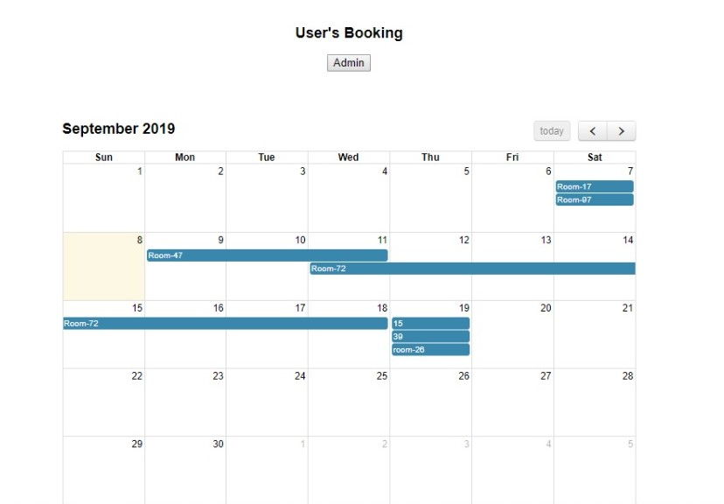

(Blue line across multiple days indicate a room being booked for multiple days.)

# 3.3 User’s List – Admin

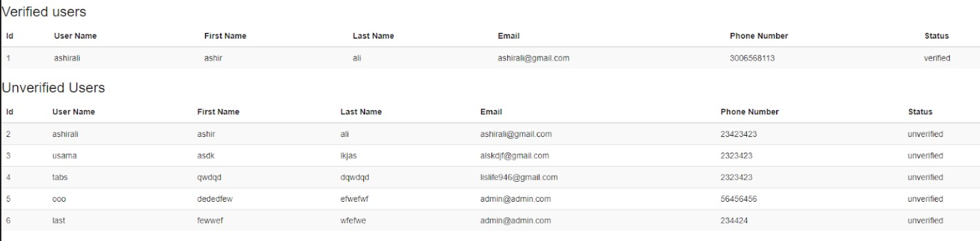

(shows the list of users who have verified their account from the email)

# 3.4 Reply to Feedback – Admin

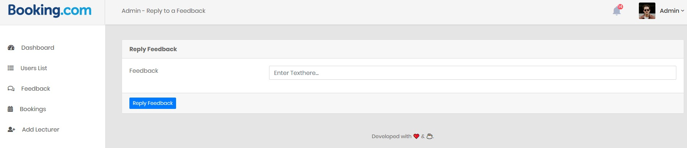

1. Click on “Reply Feedback” after typing reply to send it.
2. Enter your reply to feedback left from users

# 3.5 Dashboard – Admin

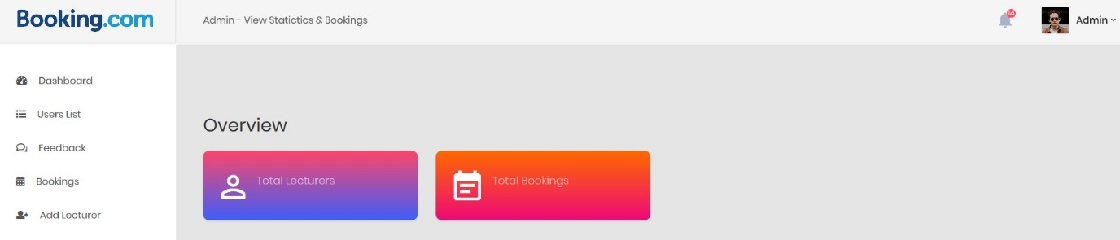

**(Shows lecturers and bookings)**